**Demonstrate how Postman is used with Jenkins**

Step-1:

First open postman and open my collection

Step-2: Then click on 3 dots then click on Run collection

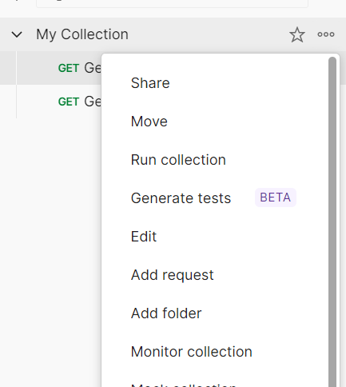

Step-3: Then I select Automate runs via cli and click on configure command

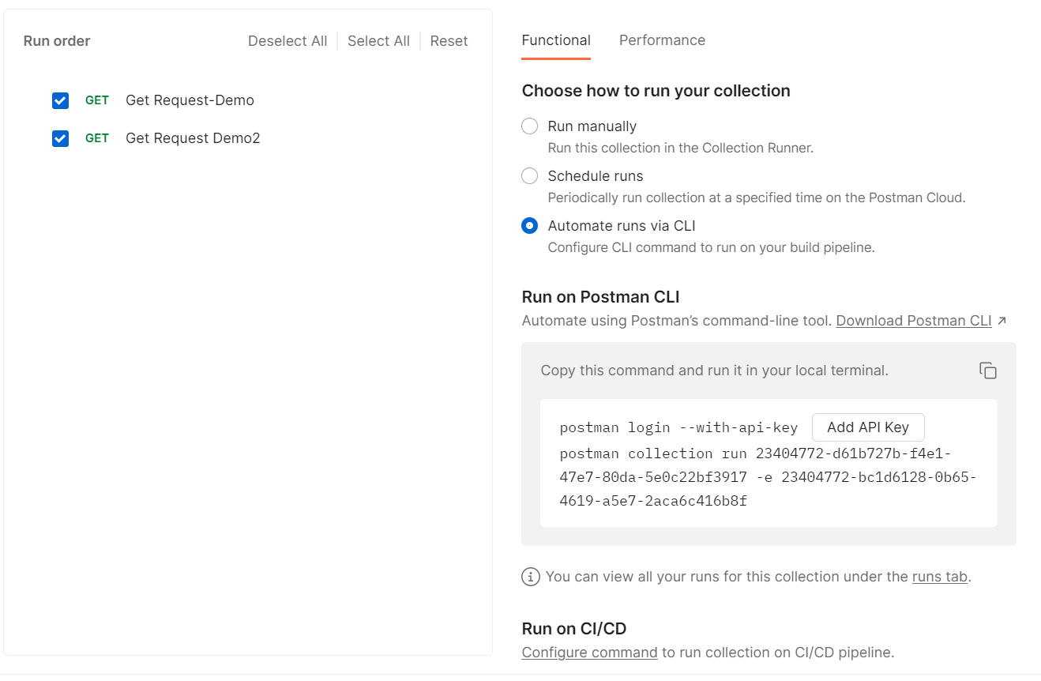

Step-4:

Here I configured it

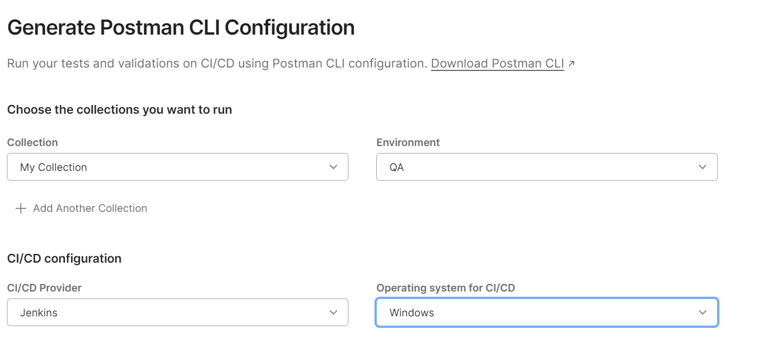

Step-5:

Then I open Jenkins and click on new item



Step-6:Here I select pipeline and enter name then click on ok

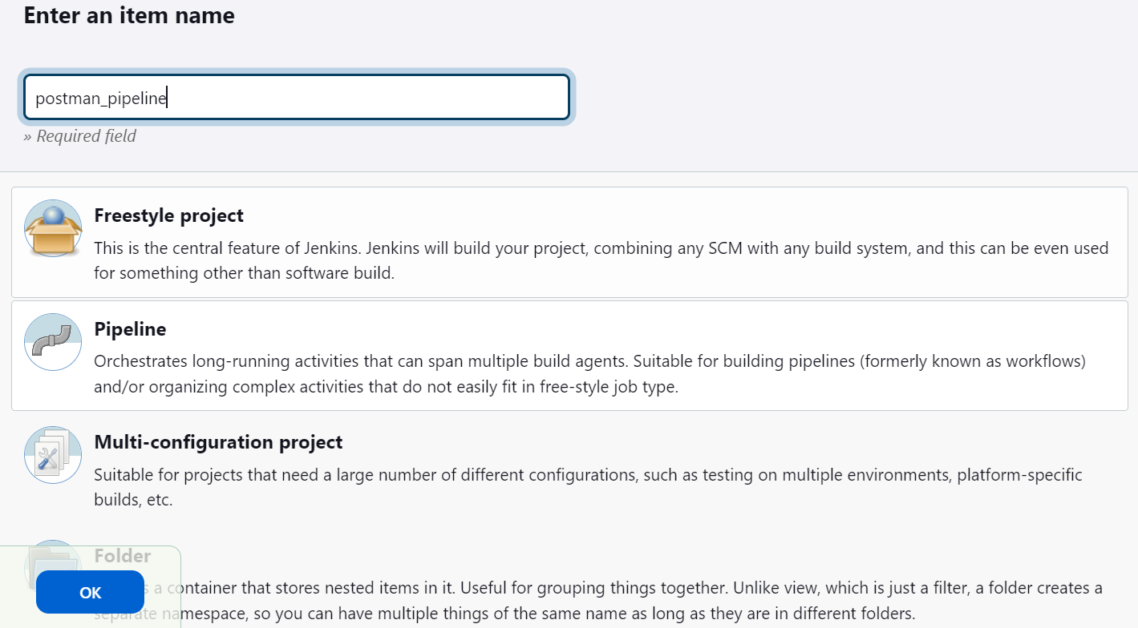

Step-7: Then I copy the script from postman

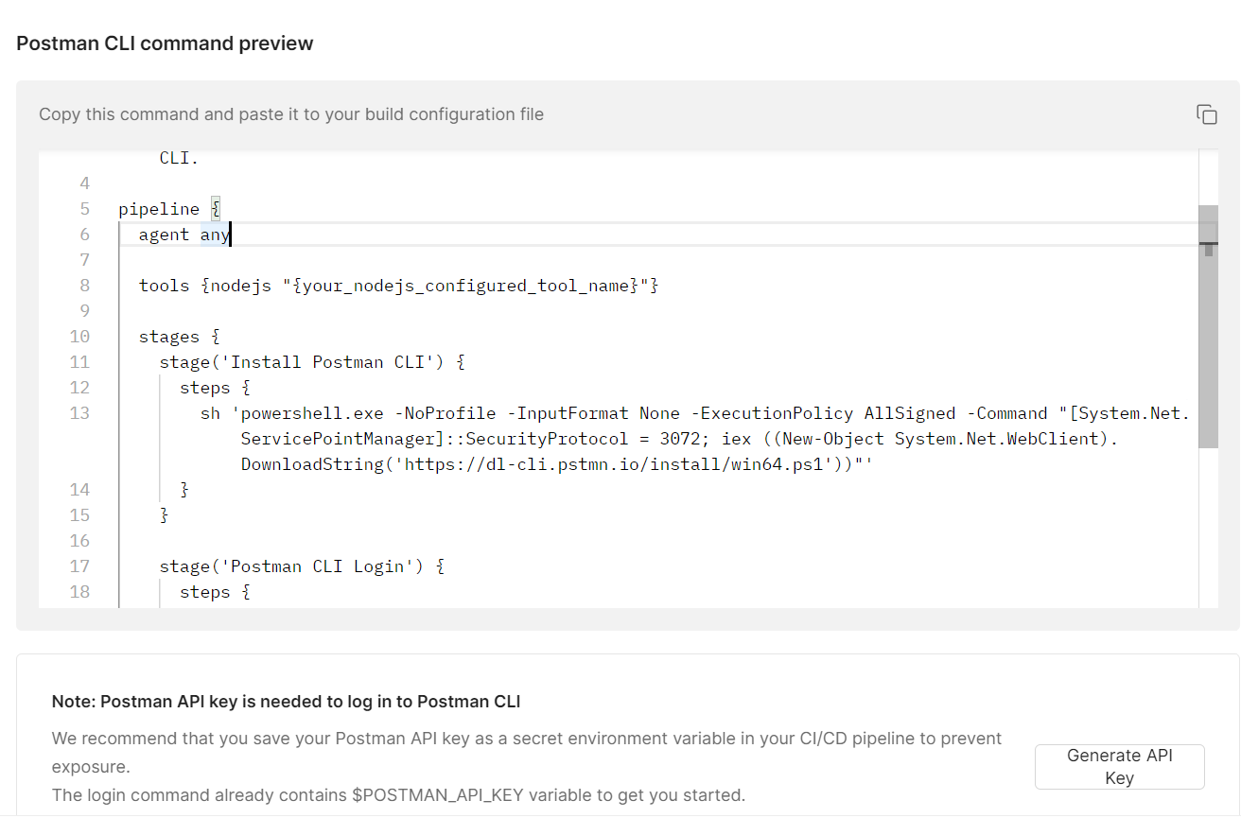

Step-8: Here I generate my pipeline script

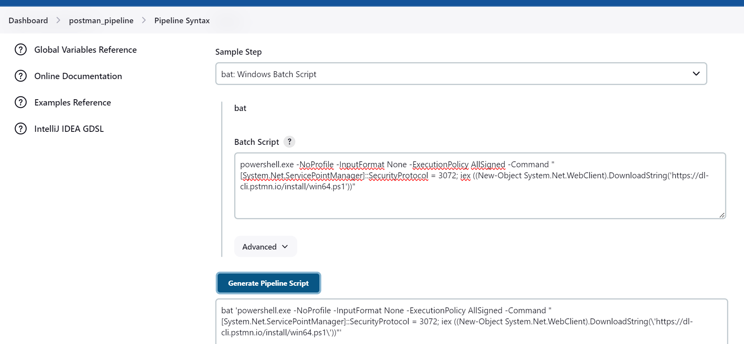

Step-9: In pipeline section I give the script and save it

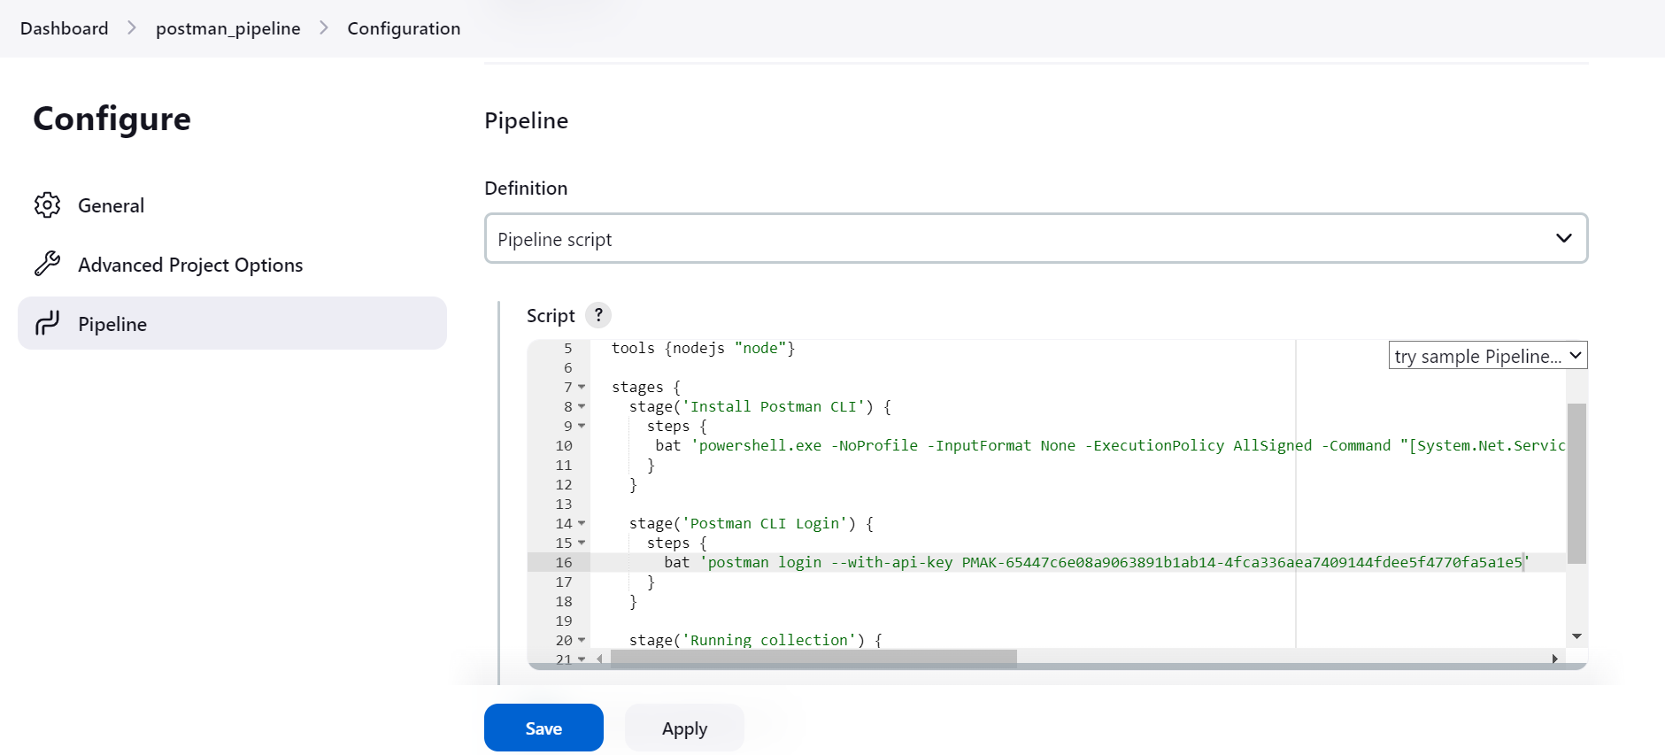

Step-10: Then click on Buid Now

